**LAB-9**

**Binary to Gray code convertor and vice versa**

**Equipment/Components**

**Hardware:** Explorer Board

IC Type 7408 Quadruple 2-input AND gates

IC Type 7486 Quadruple 2-input XOR gate

IC Type 7432 Quadruple 2-input OR gates

IC Type 7404 Hex Inverter

**Software:** Circuit Maker, Waveform

**Description**

In this lab combinational logic circuits are implemented using ‘and’ ‘or’ and ‘not’ gate on Circuit Maker and Explorer Board. After the lab students will be able to understand the functionality of odd and even parity and how to implement the circuit for gray to binary conversion and vice versa.

**Objectives**

* To learn and understand troubleshooting of Combinational logic circuits
* To Implement Binary to Gray code converter on Hardware

**Task # 1**

1. Fill the truth table for three bits Binary to Gray code conversion.

|  |  |  |  |  |  |
| --- | --- | --- | --- | --- | --- |
| **A0** | **A1** | **A2** | **B0** | **B1** | **B2** |
| 0 | 0 | 0 | 0 | 0 | 0 |
| 0 | 0 | 1 | 0 | 0 | 1 |
| 0 | 1 | 0 | 0 | 1 | 1 |
| 0 | 1 | 1 | 0 | 1 | 0 |
| 1 | 0 | 0 | 1 | 1 | 0 |
| 1 | 0 | 1 | 1 | 1 | 1 |
| 1 | 1 | 0 | 1 | 0 | 1 |
| 1 | 1 | 1 | 1 | 0 | 0 |

1. Draw a **simplified** circuit on Circuit Maker and verify the above truth table.

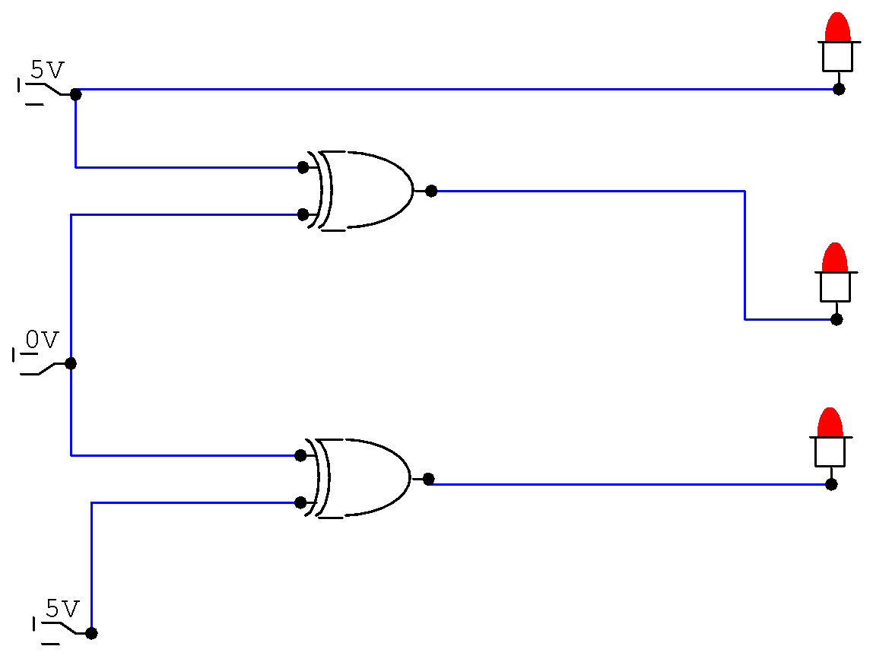

1. Fill the truth table after implementation of the simplified circuit on Explorer Board.
2. Comments on the result of part (a), (b) and (c).

**Task # 2**

1. Fill the truth table for Gray code to Binary conversion. Where A2 and B2 are the most significant bits and A0 and B0 are the least significant bits.

|  |  |  |  |  |  |
| --- | --- | --- | --- | --- | --- |
| Inputs (Gray Code) | | | Output (Binary) | | |
| A2 | A1 | A0 | B2 | B1 | B0 |
| 0 | 0 | 0 | 0 | 0 | 0 |
| 0 | 0 | 1 | 0 | 0 | 1 |
| 0 | 1 | 0 | 0 | 1 | 1 |
| 0 | 1 | 1 | 0 | 1 | 0 |
| 1 | 0 | 0 | 1 | 1 | 1 |
| 1 | 0 | 1 | 1 | 1 | 0 |
| 1 | 1 | 0 | 1 | 0 | 0 |
| 1 | 1 | 1 | 1 | 0 | 1 |

1. Draw a **simplified** circuit on Circuit Maker which converts three input binary number into corresponding gray code. Verify the above truth table.

|  |
| --- |
|  |

**Task # 3**

